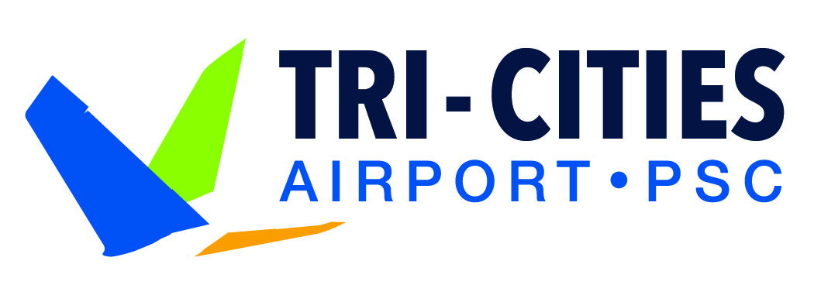

For Immediate Release For Information:
November 23, 2020 Buck Taft
547-6352

Key Information for Traveling Through Tri-Cities Airport
During the Holiday Season

Pasco, WA – The Thanksgiving holiday traditionally marks the beginning of a busy air travel season. While pandemic restrictions are in effect across the country, the Tri-Cities Airport is an essential service provider and continues to support the Tri-Cities community. For those who choose to travel during this the holiday season, please keep in mind the following:

Face coverings are required throughout the terminal. When coming to the airport, all visitors must wear a mask or face covering.

Health and safety measures are in place. In addition to a mask requirement, the airport has installed several features to minimize person-to-person contact, including social distance markers, plexiglass windows, and restricted seating.

Greet passengers on the curb. When picking up someone from the airport, please use the cell phone lot and have the passenger call you when they arrive and have their bags. You can then pick them up on the curb. If you need to come into the airport, we ask that only one person comes in to meet the passenger and to comply with health and safety requirements.

Dining options are still available. The airport’s concessionaires are providing grab-and-go food options for travelers, and the airport store remains open and selling snacks, bottled drinks, and other items.

Think 3-1-1. When going through the security checkpoint, come prepared to follow the 3-1-1 rule for your liquids and gels: 3 ounces of liquid in a 1 quart bag, 1 bag per person. Higher quantities of breast milk, medicines, and hand sanitizer are permitted but may require further inspection.

Know Which Holiday Items Can Travel in Your Carry-on. The Transportation Security Administration (TSA) has policies that affect holiday travel. Learn ahead of time which items you can bring on the plane or need to check in your luggage.
- Wrapped gifts: While you can travel with wrapped presents, if your gift triggers an alarm at the checkpoint, it may need to be unwrapped for TSA officers to inspect. Instead of wrapping, consider using a gift bag or a gift box (which allows officers to remove the item without needing to unwrap it) or wrap the gift upon your arrival at your destination.
- Holiday foods: Solids like cookies or ham can be carried onto the plane in your bag. But if you can spill it, spread it, spray it, pump it or pour it, then please pack anything over 3.4 ounces in your checked bag. This includes gravies, jams, and jellied cranberries.
- Snow globes: Snow globes are popular holiday gifts, but if you’re traveling with a snow globe, it needs to contain 3.4 liquid ounces or less to be in your carry-on. TSA’s rule of thumb is that if it is smaller than a tennis ball, it is probably 3.4 ounces or less.

Plan ahead. The airport has created a fun and informative video that details the new travel procedures in place. Prepare for your trip by watching the video here.

For additional details on how the Tri-Cities Airport is responding to COVID-19, please visit our website.

About the Airport
Tri-Cities Airport (PSC) is the largest airport in the Southeastern Washington and Northeastern Oregon region and the third largest air carrier airport in the state of Washington. With connections to eight major hubs, the airport is served by Delta, Alaska, United, and Allegiant airlines. More than 870,000 passengers traveled through PSC in 2019. For more information about the airport, visit flytricities.com or follow us on Facebook.

