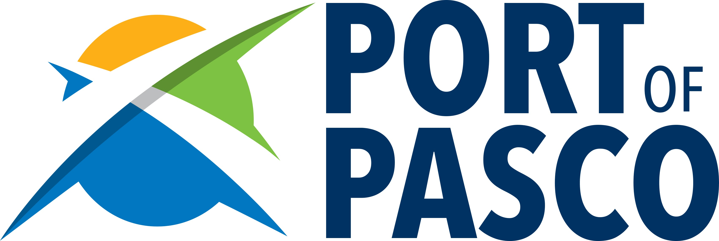

For Immediate Release For Information:
April 27, 2021 Randy Hayden
Executive Director
547-3378

Capital Budget includes $7.5 million for Reimann Industrial Center
Pasco, WA – The Capital Budget, approved late last week by the Washington State Legislature, will deliver $7.5 million in funding to construct infrastructure to serve the Port of Pasco’s new Reimann Industrial Center.

A large allocation for infrastructure, the funding will make it possible for the Port and its community partners to begin Phase 1 of development. When complete, the Reimann Industrial Center is expected to create more than 1,000 manufacturing jobs and inject over $10 million in new property taxes into Franklin County. The state Capital Budget funding is contingent upon a new large ag processor officially committing to locate at the Reimann Industrial Center.

“Port of Pasco’s Commissioners are pleased and grateful for the Washington Legislature’s funding of the Reimann Industrial Center project,” said Commission President Jim Klindworth. “We appreciate their vote of confidence in the Port, and its ability to create successful economic development projects.”

The port district received support from all local legislators in the 8th, 9th, and 16th Districts. Klindworth also acknowledged the support of the Senate and House Capital Budget Committees and leaders of those committees.

The 300-acre Reimann Industrial Center is the Port’s newest development area. Currently undeveloped, the Reimann is on the East side of Railroad Avenue between Foster Wells Road and Vineyard Avenue.

State funds will be combined with the Port’s own investment from its Economic Development Opportunity Fund as well as support from other local partners. The Phase 1 project will cost an estimated $15.8 million. The funds will install a water main, sewer main, railroad crossing and rail spur, broadband, and improvements to a portion of Railroad Avenue to include left-hand turn lanes into the Reimann.

“This has been a coordinated team effort over several months,” said Executive Director Randy Hayden. “The Port appreciates all the hard work and effort by our state legislators, the City of Pasco, Franklin County, Franklin PUD, TRIDEC and many others.”

Developing the Reimann will continue the Port’s successful tradition of establishing industrial development projects that have historically attracted food processing, cold storage, and distribution facilities.

* * * * *

