For Immediate Release For Information:
June 12, 2018 Don Faley
(509) 537-0511

New Hotel to Break Ground at Tri-Cities Airport Business Center

Travelers rejoice: Marriott is bringing its Courtyard brand to the Tri-Cities Airport. The airport, owned by the Port of Pasco, has reached an agreement with A-1 Hospitality on a ground lease at the corner of Argent Avenue and N. 20th allowing the franchise hotel project to move forward with construction. The Courtyard by Marriott – Tri-Cities/Pasco Airport will open in the Airport Business Center in 2019.
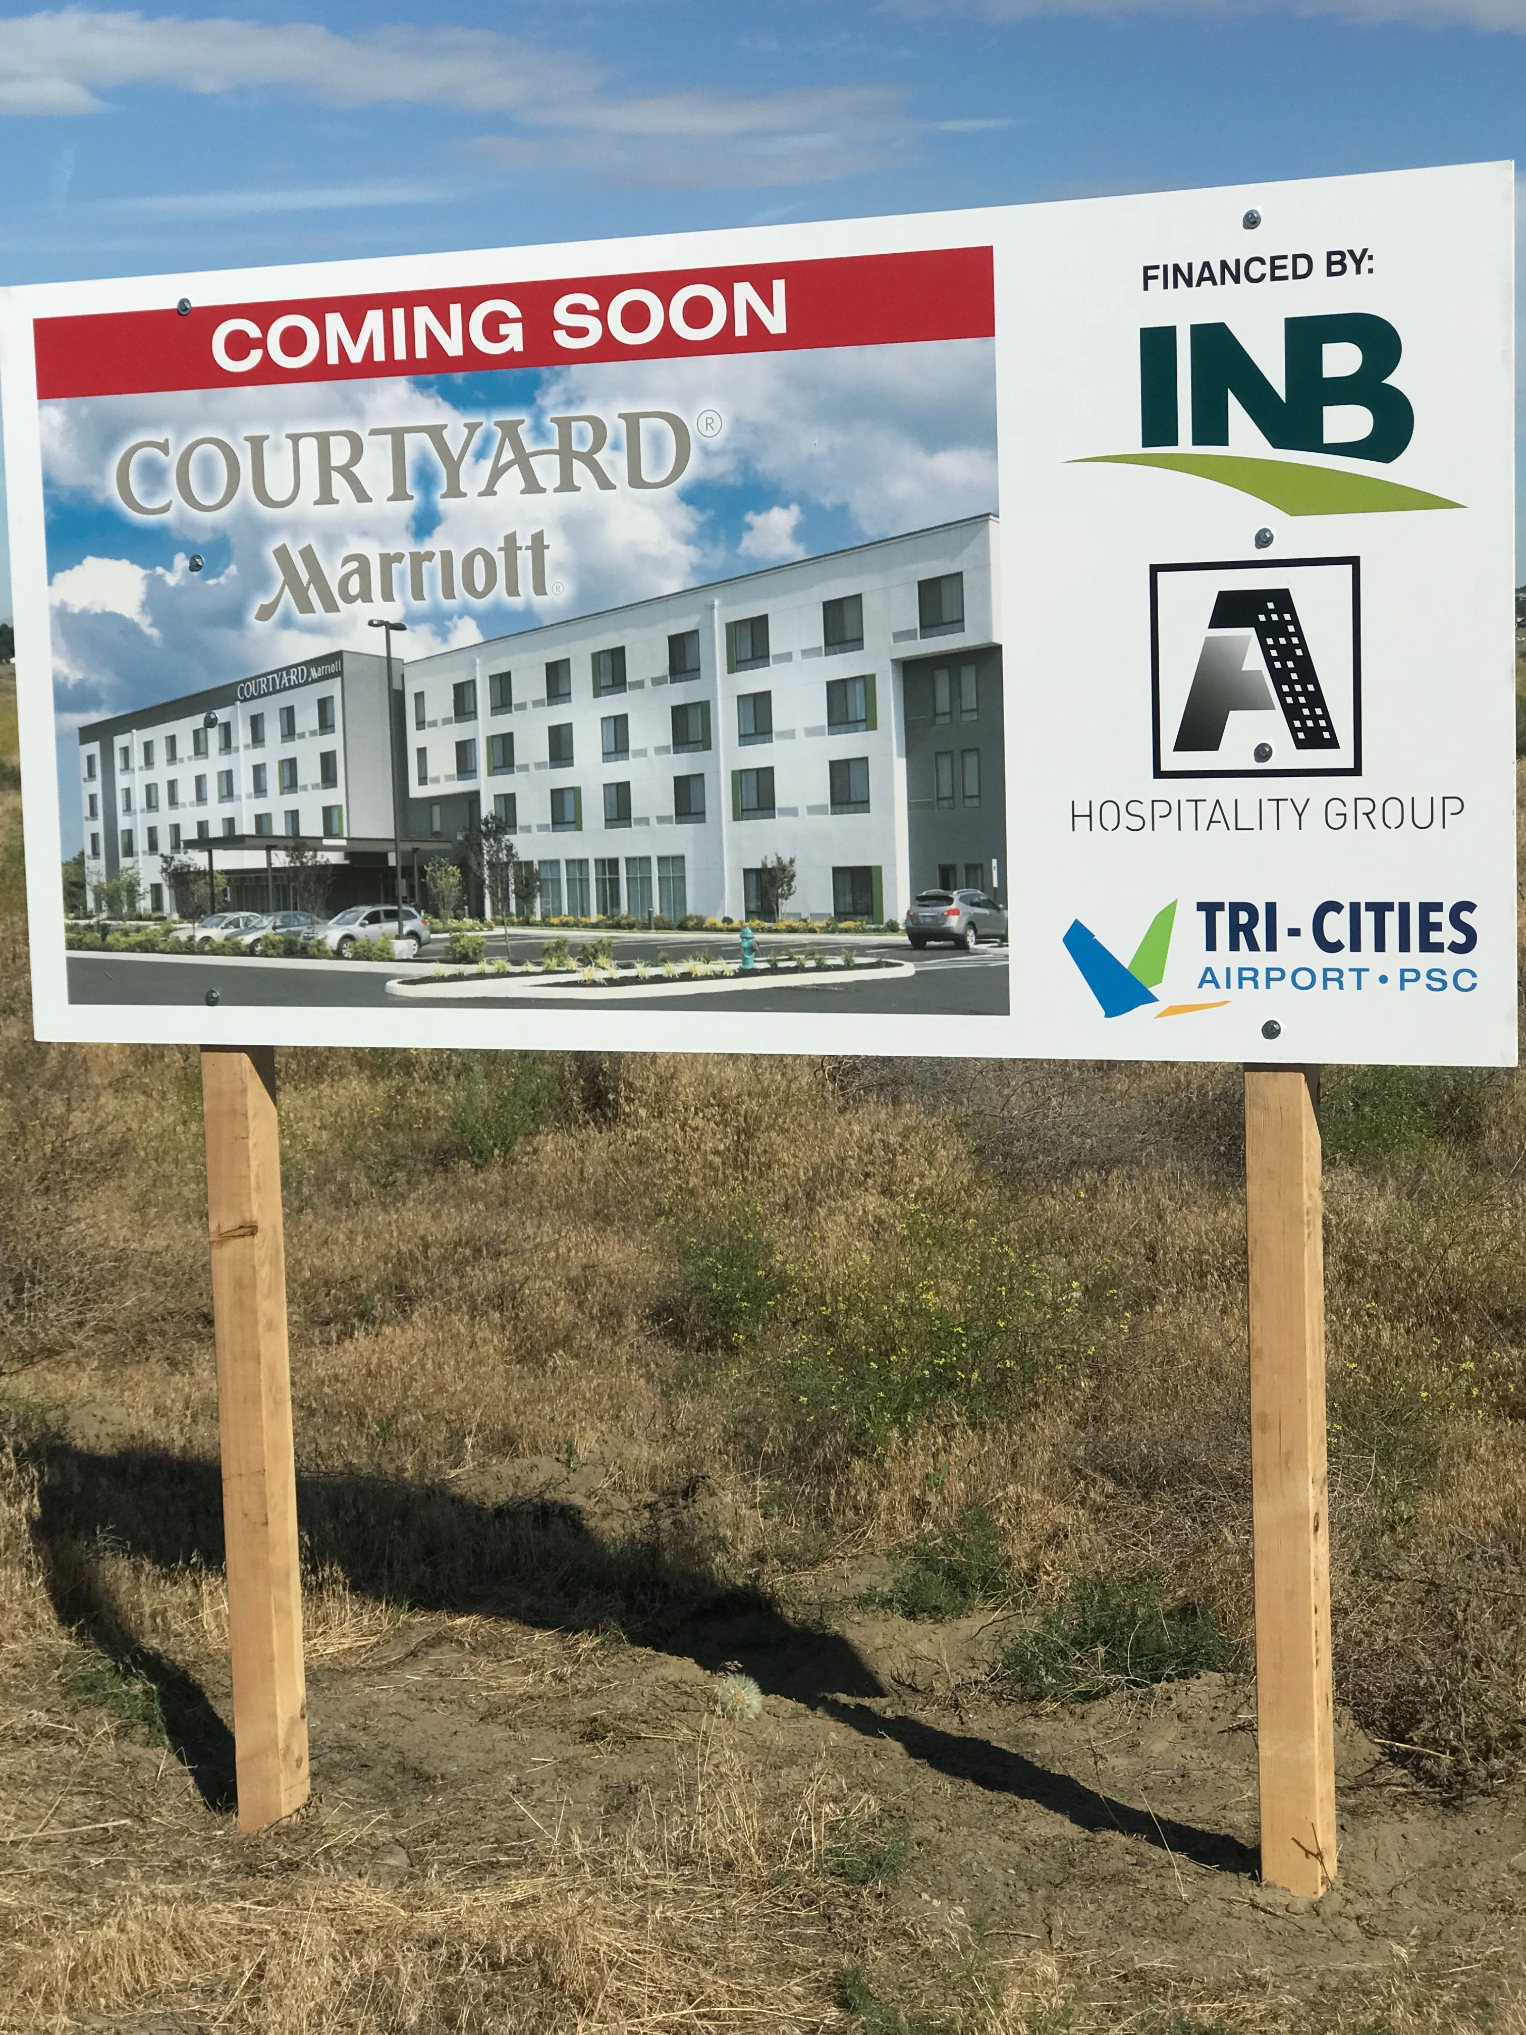
The four-story, business-traveler focused hotel will host 99 rooms, indoor pool, fitness center, boardroom, and a fast casual bistro serving as a coffee bar by day and cocktail bar in the evenings.

The Courtyard by Marriott is being developed by A-1 Hospitality Group, and the hotel will be managed by A-1’s Columbia Hotel Management arm. Idaho-based JRA Architecture and Planning is designing the hotel’s architect, and Fowler General Construction of Richland is the general contractor. The project is financed by Inland Northwest Bank of Spokane, WA.

“This hotel is an important addition to the airport and the neighborhood,” said Buck Taft, Director of Tri-Cities Airport. “The proximity to the airport provides the traveling public a convenient and affordable option while staying in the Tri-Cities, and it will also support Columbia Basin College and its visiting guests, students and families.”

A-1 currently owns and operates the Holiday Inn Express and Suites on Rd 68 in Pasco, and additional hotel properties in Oregon. “We are thrilled to bring the exceptional Courtyard brand to the Tri-Cities Airport. This corporate-centric hotel will provide much needed modern upscale lodging to the airport community,” stated A-1’s Managing Member Taran Patel. “Our experienced management team will provide unparalleled guest service in a clean and modern environment. We look forward to constructing a hotel that will not only accelerate further economic development in the Airport Business Center but also the surrounding areas.”

“Courtyard has long led the industry when meeting the needs of the modern business traveler since breaking into the market 30 years ago. Courtyard has continuously evolved, pushing the boundaries of design, style and service in the upscale category – introducing game changing amenities like the Bistro fast casual restaurant and collaborative lobby spaces. As the 8th largest lodging brand in the world, with over 1,100 hotels in 47 countries, Courtyard continues to expand globally into urban locations, downtown markets and high-visibility destinations”, stated Marriott International

Construction begins this fall.

